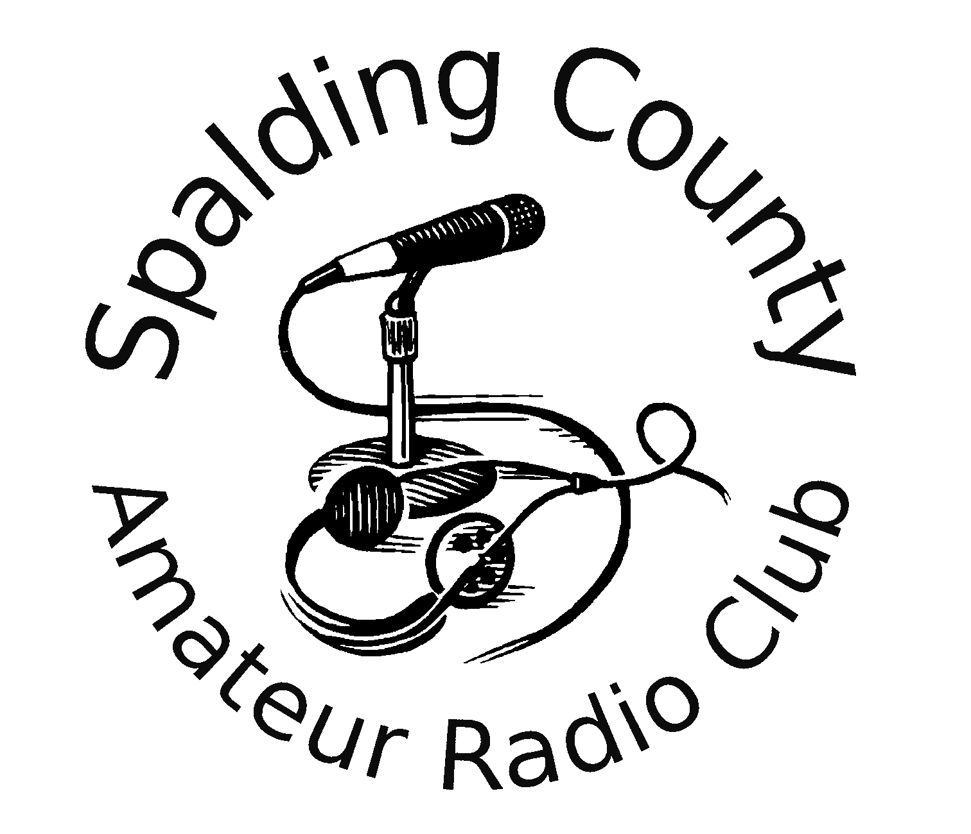
Spalding County Amateur Radio Club
K4CXS
New Member Application Member Information Update
Please Print Plainly and Fill in All Spaces. Use back of sheet if needed.
Membership dues are due in January or at the time of Membership acceptance if a new member.

Date: _____________
First Name:________________________ Last Name: _______________________
Address:___________________________________________________________
City; _________________ State: _________ Zip:________________
Phone: ___________________________
Callsign: ____________Class:______________ ARRL member?
Email Address:______________________________________________________
No personal information will be shared with anyone outside the Spalding County Amateur Radio Club.
Bands you operate on:________________________________________________
Modes (list all digital modes):___________________________________________
__________________________________________________________________
Equipment or modes that you would like to learn:___________________________
__________________________________________________________________
__________________________________________________________________
I understand that as a member of this club, I must adhere to FCC rules and regulations and any violation may result in the loss of Spalding County Amateur Radio Club membership.
Officer Use Only
Approved Declined
_________________________________________________
Signature

__________________________________ ___________________________________
President Signature Other Officer Signature

